**1.What is the percentage of unique product increase in 2021 vs. 2020?**

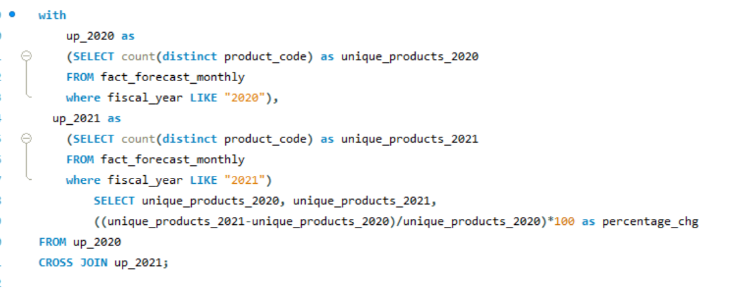

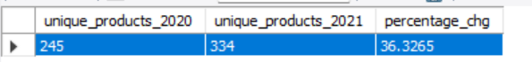**Result**

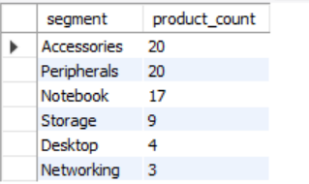**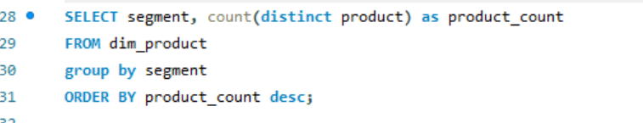2.Provide a report with all the unique product counts for each segment and sort them in descending order of product counts.**

**Result**

**3.Which segment had the most increase in unique products in 2021 vs 2020?**

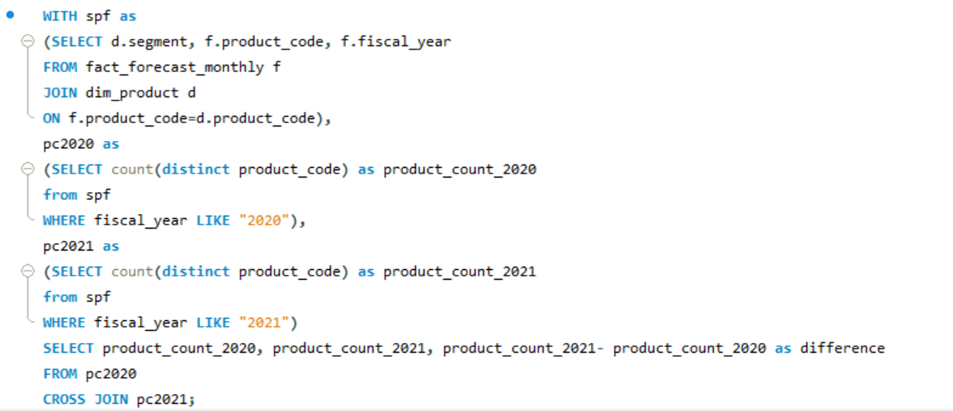**Result**

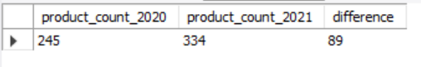

**4. Get the products that have the highest and lowest manufacturing costs.**

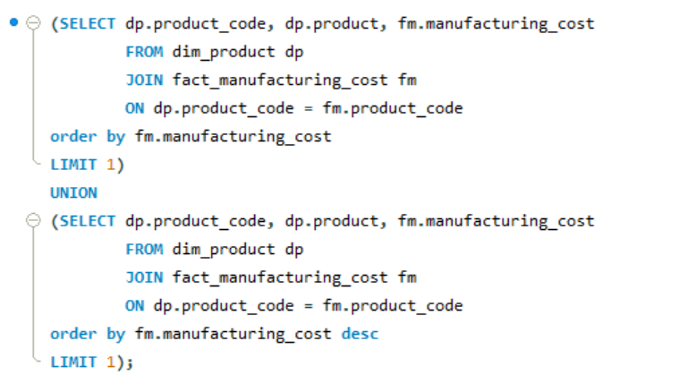

**Solution**

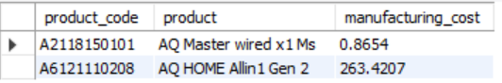

**5. Generate a report which contains the top 5 customers who received an average high pre_invoice_discount_pct for the fiscal year 2021 and in the Indian market.**

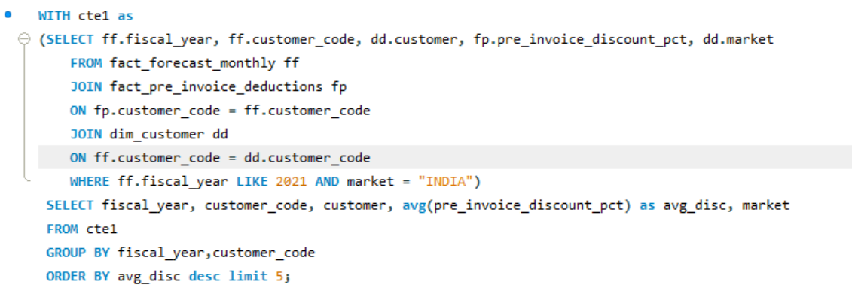

**Result**

**6. which quarter of 2020, got the maximum total_sold_quantity?**

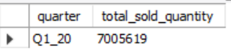**Result**

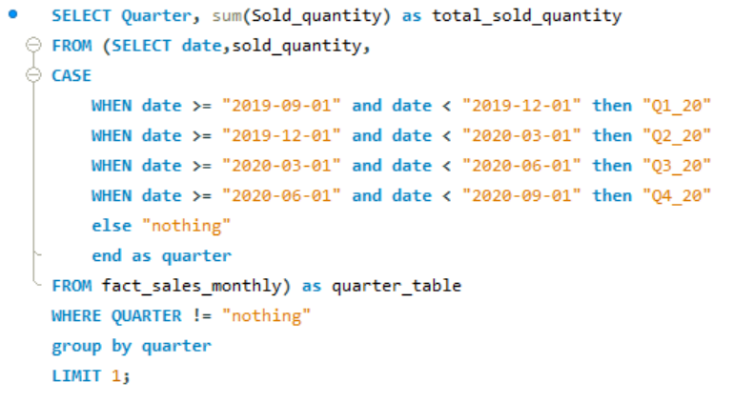 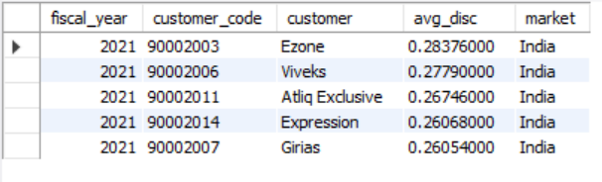

**7.Which channel helped to bring more gross sales in the fiscal year 2021 and the percentage of contribution?**

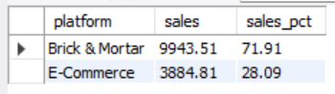

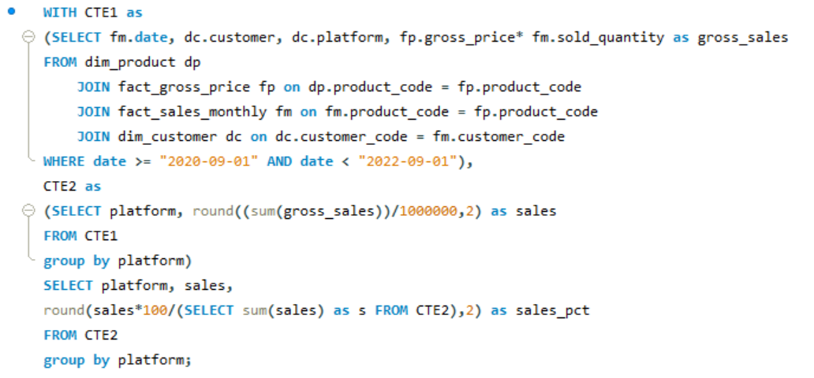**Result**

**8. Get the Top 3 products in each division that have a high total_sold_quantity in the fiscal_year 2021**

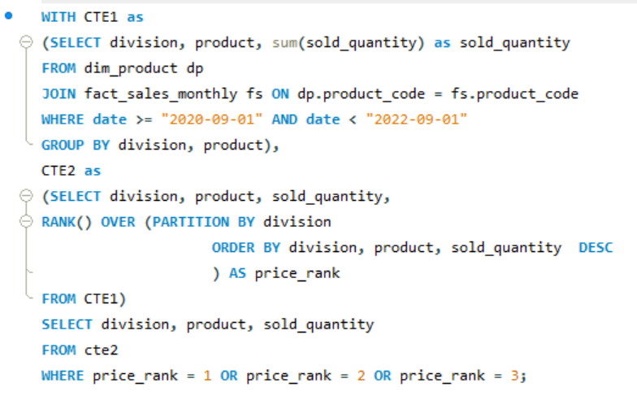

**Result**

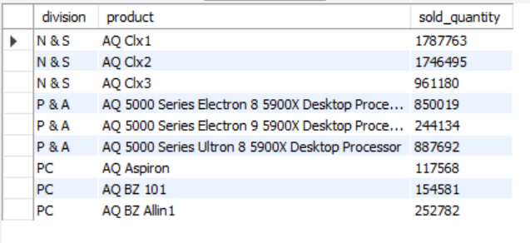

**9. Get the complete report of the Gross sales amount for the customer “Atliq Exclusive” for each month.**

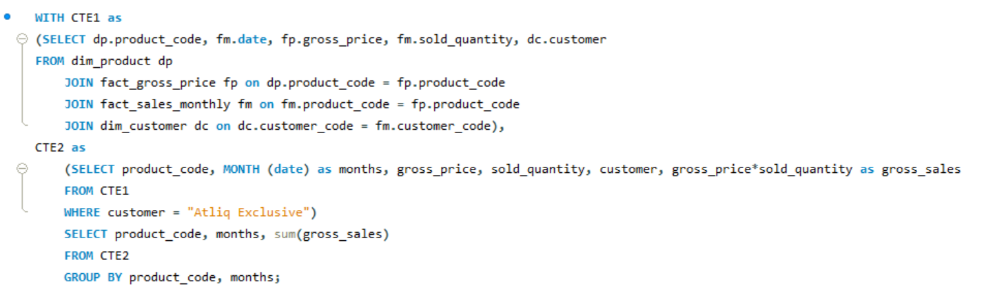

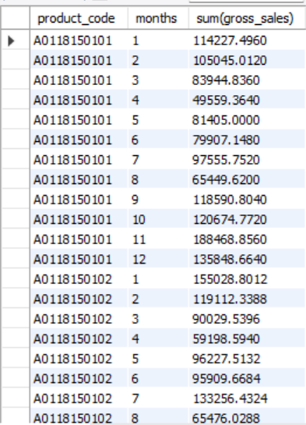**Result**